INSTITUTE OF PUBLIC ADMINISTRATION AND MANAGEMENT

(UNIVERSITY OF SIERRA LEONE)

INFORMATION SYSTEMS YEAR 3

ISM 322 SOFTWARE ENGINEERING II GROUP 5 PROJECT (SEMESTER 2)

USER DOCUMENTATION

THE SEARCH ROUTE

on this page of the system, the user is being provided with two textboxes where in the user is being able to input his or her to and fro destination and a button which enable the user to click and then search available route destinations

if the route being input is not available it will display an blank page showing that the route destination is unavailable at the moment to wait as the destination will be added within the shortest possible time of you contact the support.

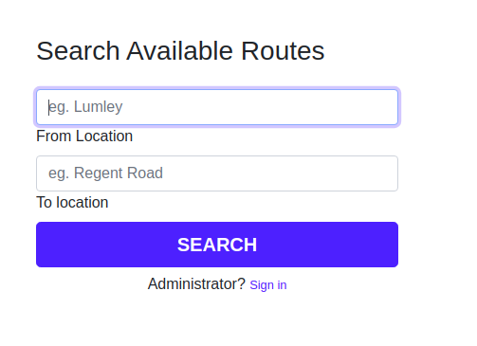

THE SEARCH RESULT

If the route is available, the user will be presented with a list of the available routes and the user then proceed to click on the desired route to perform payment for the reservation

THE PAYMENT PAGE

From the search result where the user has search for available routes, he or she will then be take to a the payment page where the pay the user will be presented just a demo payment page and then the user should input the credit card details to proceed the payment.

PAYMENT CONFIRMATION

From the payment page where the user has completed the payment requirement, if the payment is successful, provided that the user input correct details, it will then take him or her to a confirmation page telling the user that the payment has been confirmed and it will present the user with an ID number which will serve as the ticket ID.

SING UP

If the user want o be keeping track of his or her activities

he or she is provided with a sign in page to input his or her details and then the user should confirm his or her sign up and start using the system seamlessly

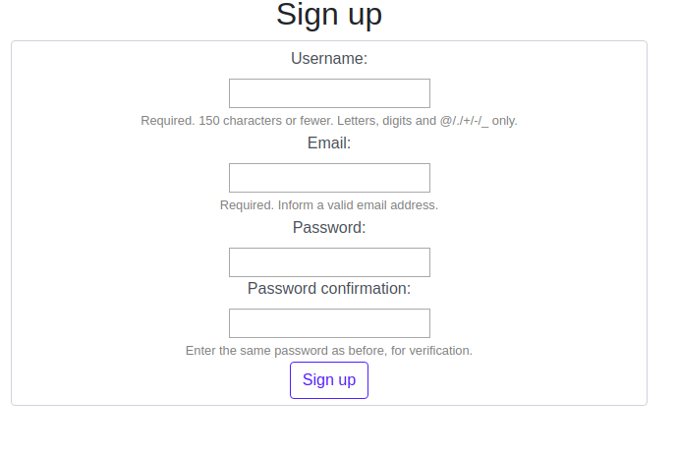

SIGN IN

The sign in just like the sign up allows the user to sign in the system

and view reservation

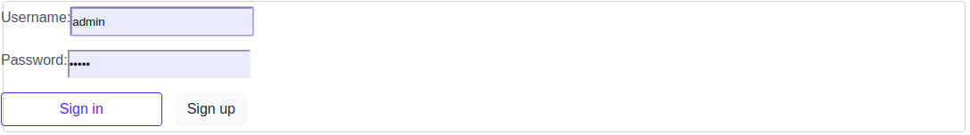

VIEW RESERVATION

This allows the user after sign up and signing to the system to view all the reservation the user has mad and the user is even given the chance to cancel reservation